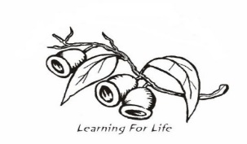
Coolbellup Community School and Coolbellup Learning Centre
P&C Association Inc.
Paid in Full
Delivered
Receipt #
2019 UNIFORM ORDER FORM

Please return your order form with payment in full to school office or Uniform Shop.

Please note, we do not have eftpos facilities.

Payment Options:
Direct Bank Payment: CCS and CLC P&C Association
Commonwealth BSB 066-190 A/C 10188616 (include student name)
Cheque (made payable to CCS and CLC P&C Association) or
Cash

*** Items will not be provided until monies have cleared.

STUDENT’S NAME: ____________________________________ LA: ____

PARENT’S NAME: _____________________________________

PHONE: ______________________ EMAIL: __________________________

 |  | SIZE
STYLE | PRICE | 2 | 4 | 6 | 8 | 10 | 12 | 14 |  | 16 |  | ADULT | TOTAL
Polo Shirt | $27.00
Black Fleece Zip Jacket | $30.00
Adult sizes available in some designs. Please enquire as to price and availability. |  |  |  |  |  |  |  |  |  |  | TOTAL

Please choose sizes and styles carefully as items cannot be exchanged or refunded.
Note: Some styles require 8-10 weeks.

Uniform Shop Opening Hours:
Tuesday 8.30 – 9.00am
Thursday 8.30 to 9.00am

